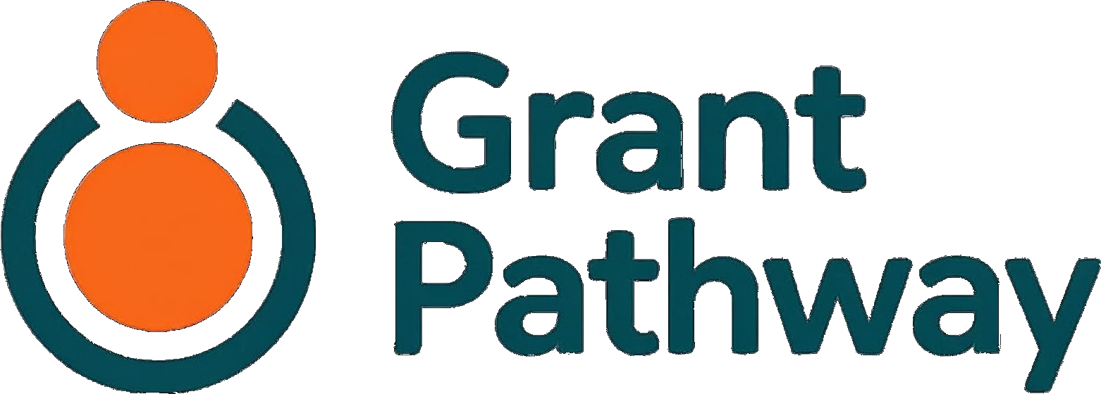

User Guide

A step-by-step guide to preparing your grant application
Service provided by :
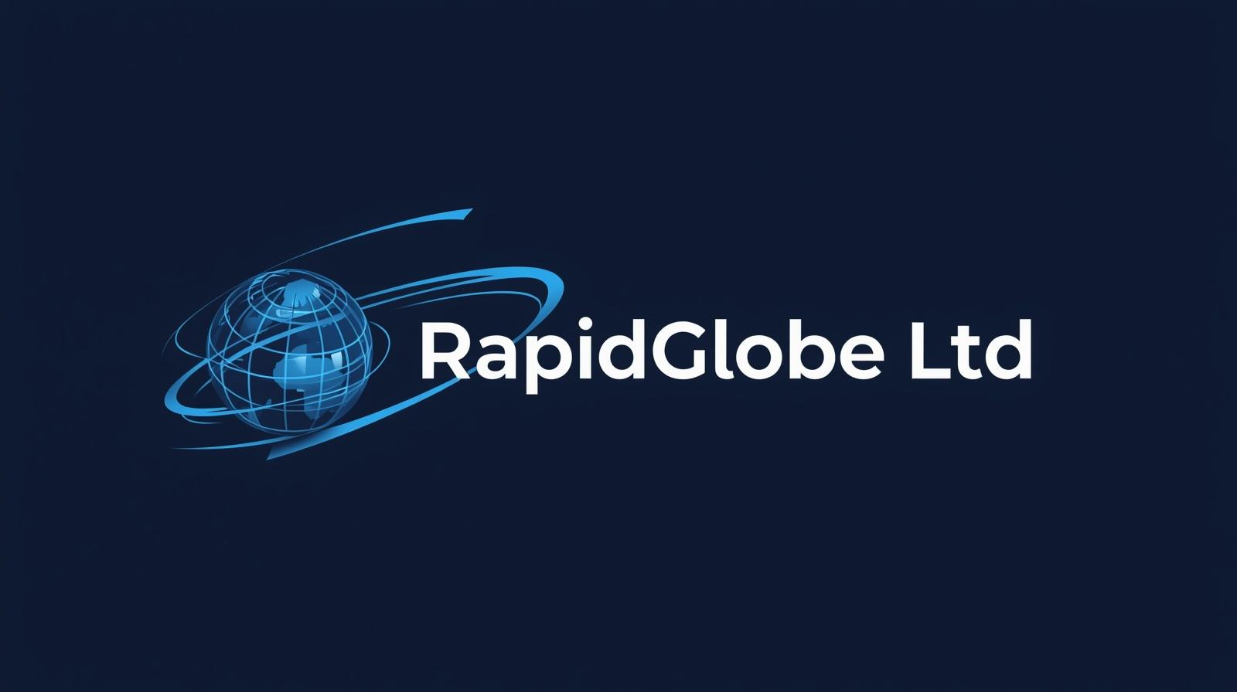
June 2026
Version 1.14

Welcome to Grant Pathway

Grant Pathway helps your charity prepare stronger grant applications. It reads a funder’s guidelines, pulls out the key questions they want you to answer, and gives you a structured space to write — and refine — each answer with optional AI support.

Every word in your application is written by you. Grant Pathway helps you stay organised, keep within word limits, and polish your answers before you export them as a ready-to-submit Word document.

This guide is organised in two parts.

Contents
Welcome to Grant Pathway 2
Contents 2
How to Use This Guide 3
Part A — Using Grant Pathway 3
1. Signing In 3
2. Your Dashboard 3
3. Choose Your Funder and Grant 4
4. Upload the Funder’s Guidelines 5
Upload a File 5
Paste Text 5
5. Review the Summary 7
6. Before You Begin Writing 8
7. Write Your Answers 10
Writing Your Answer 10
Word and Character Limits 10
Getting AI Help 10
Sections with Financial Information 11
Approving Answers 11
8. Prior Export 13
9. Review 14
10. Export 14
Part B — First-Time Setup 15
12. Before You Start 15
13. Creating Your Account 16
14. Setting Up Your Charity Profile 19
15. Managing Your Account 23
Deleting Your Account 23
16. Application Status — What the Labels Mean 24
17. Need Help? 24

How to Use This Guide
Part A covers signing in as a returning user and starting a new application. From Section 5 onwards, the process is the same for all users — Part B will signpost you back to the relevant sections in Part A.
Part B covers everything you need to do the first time you use Grant Pathway — creating your account, setting up your charity profile, and preparing your first application.

Part A — Using Grant Pathway
This part covers the full application process and is the main reference for all users. If you are using Grant Pathway for the first time, go to Part B to set up your account, then return here to begin your application.

1. Signing In
Go to grant-pathway-three.vercel.app. Enter your Email address and Password, then click Sign in.
If you have forgotten your password, click Forgot password? and follow the instructions to reset it.

2. Your Dashboard
Once signed in, your dashboard displays all your applications. Each application shows the funder name, the grant name, its current status, and the date it was last updated.
To start a new application, click + New Application.
To continue working on an existing application, click View.
To remove an application you no longer need, click Delete.
The summary bar at the top of your applications list shows how many applications you have at each stage, and how many AI requests you have used this month.
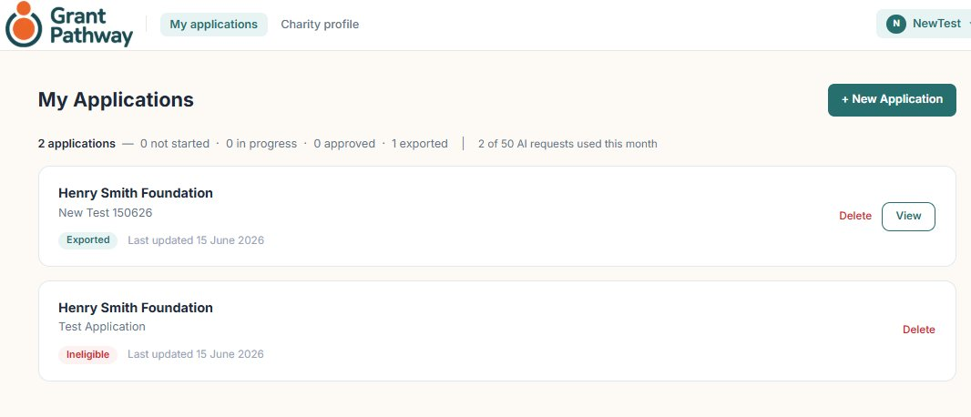
Click + New Application to begin a new application.

3. Choose Your Funder and Grant
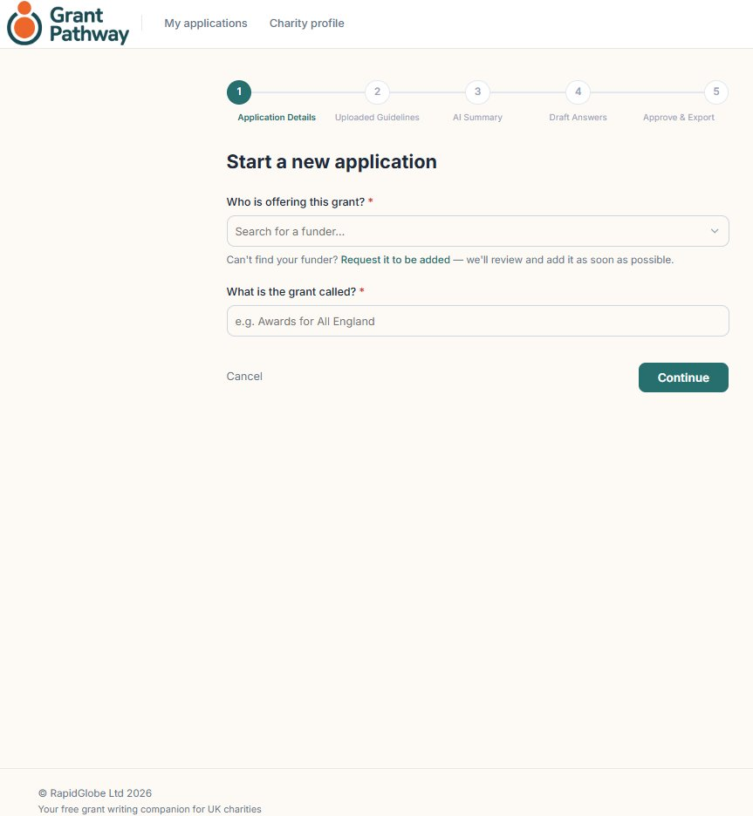

- Funder — select the grant-giving organisation you are applying to from the dropdown list.
- Grant name — type the name of the specific grant programme you are applying for (e.g. “Community Grants Programme 2026”). This is for your records and does not affect the application.

Click Continue to proceed.

4. Upload the Funder’s Guidelines
Grant Pathway reads the funder’s guidelines to understand what questions they want you to answer and what they are looking for.

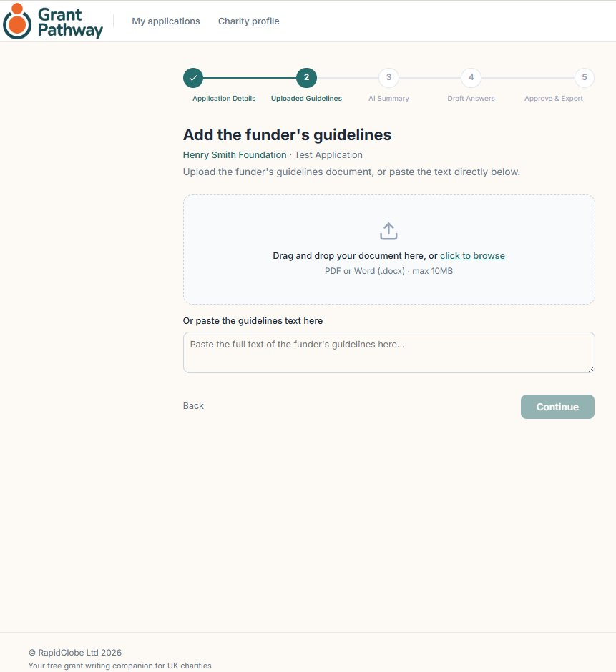

You have two options:

Upload a File
Click Choose file or drag and drop a PDF or Word document onto the upload area. This works best when the funder provides a downloadable guidelines document.

Paste Text
If the funder’s questions are on their website, click the Paste text tab and paste the relevant text into the text box.

Tip: For the best results, upload or paste the section of the guidelines that contains the application questions and assessment criteria. You do not need to include the funder’s background information or terms and conditions.
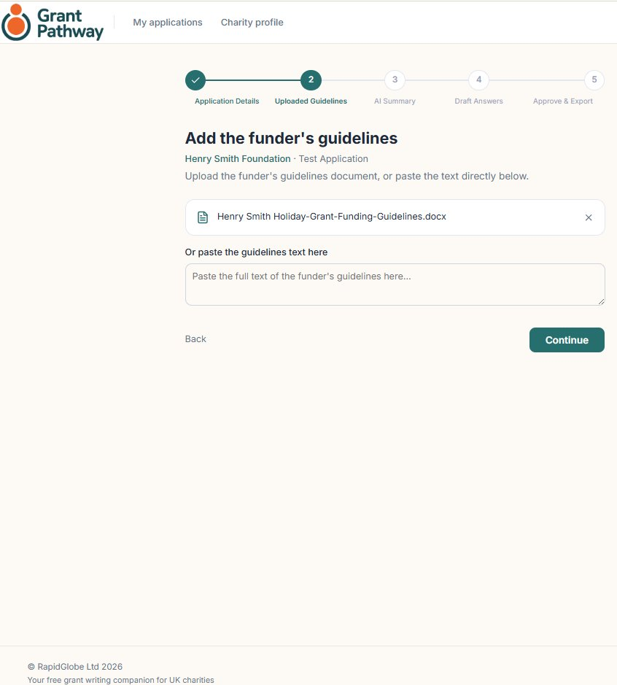
Once your guidelines are uploaded or pasted, click Continue.

5. Review the Summary
The Grant Pathway AI engine analyses the guidelines and produces a summary. This usually takes up to 45 seconds.

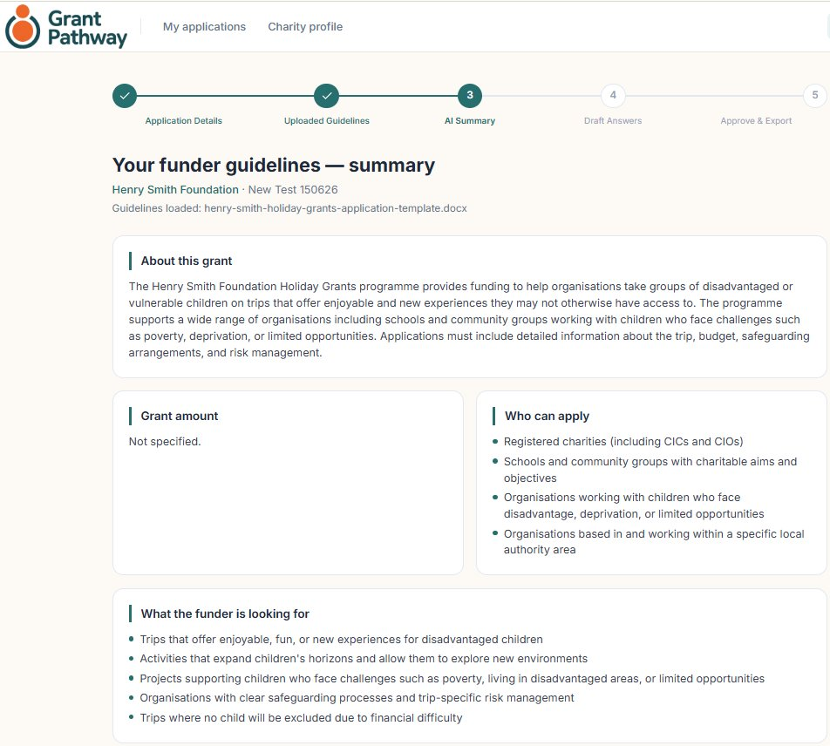

The summary screen includes:
- About this grant
- Grant amount
- Who can apply
- What the funder is looking for
- Application sections
- Key requirements

Grant Pathway will identify the sections that need to be completed before the application is submitted to the grant-issuing organisation.

When you are ready, click Continue.

Note: Eligibility mismatch
In some cases, Grant Pathway may determine that your charity is not eligible for the selected grant. If this happens, you will see an eligibility mismatch message at Step 3 — AI Summary, explaining why your application cannot proceed.
Read the message carefully — it will explain the specific reason. You can then either:
- Update your Charity profile to better reflect your charity’s work, then start a new application, or
- Select a different funder whose criteria more closely match your charity’s work.
Click I understand — return to my dashboard to go back and start again.
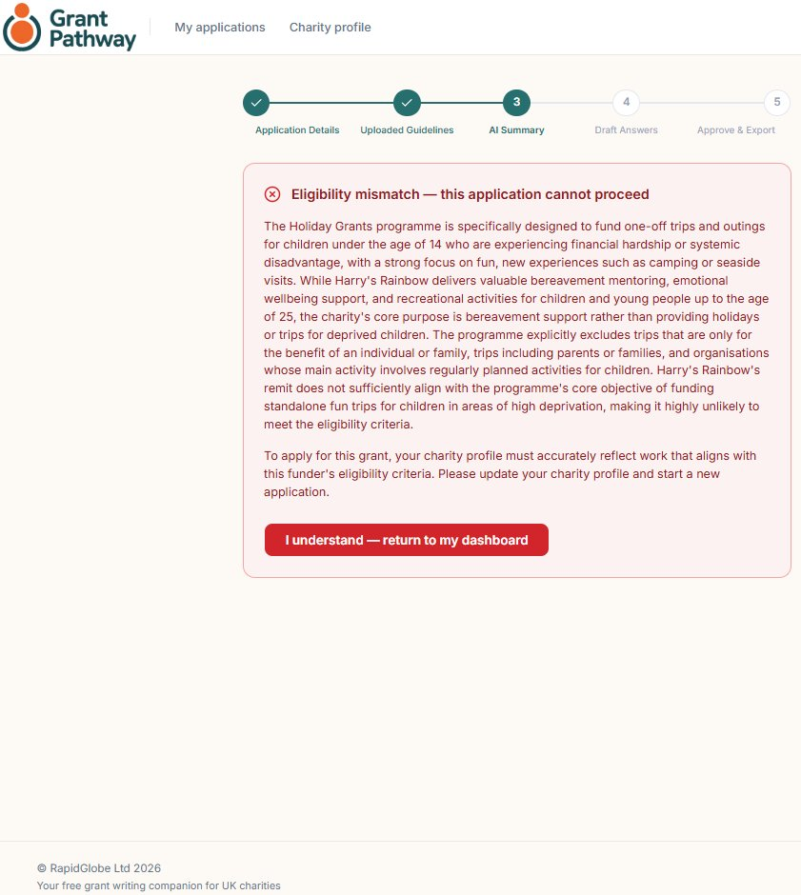

6. Before You Begin Writing

Grant Pathway will prompt you to ensure all relevant financial information is to hand before you begin writing.

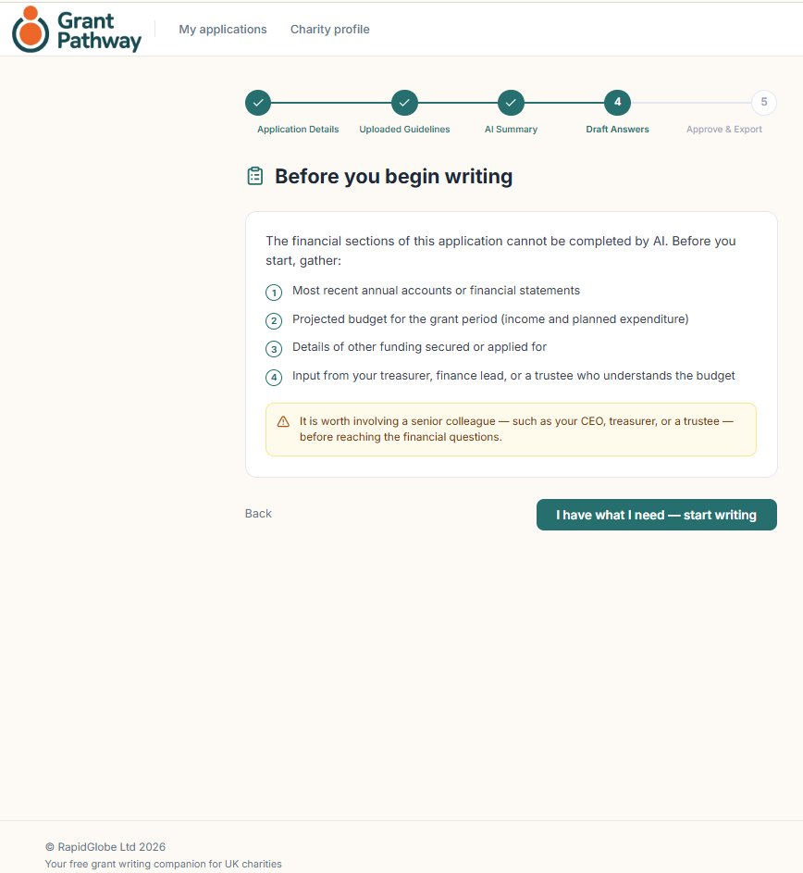

Tip: Grant Pathway allows up to 50 AI-assisted requests per calendar month per account. This covers guideline summaries, draft generation, and answer refinement. A counter on your dashboard shows how many requests you have used. A warning will appear when you are approaching this limit.

When you are ready, click I have what I need – start writing.

7. Write Your Answers
Each question or section extracted from the guidelines appears as a separate card.
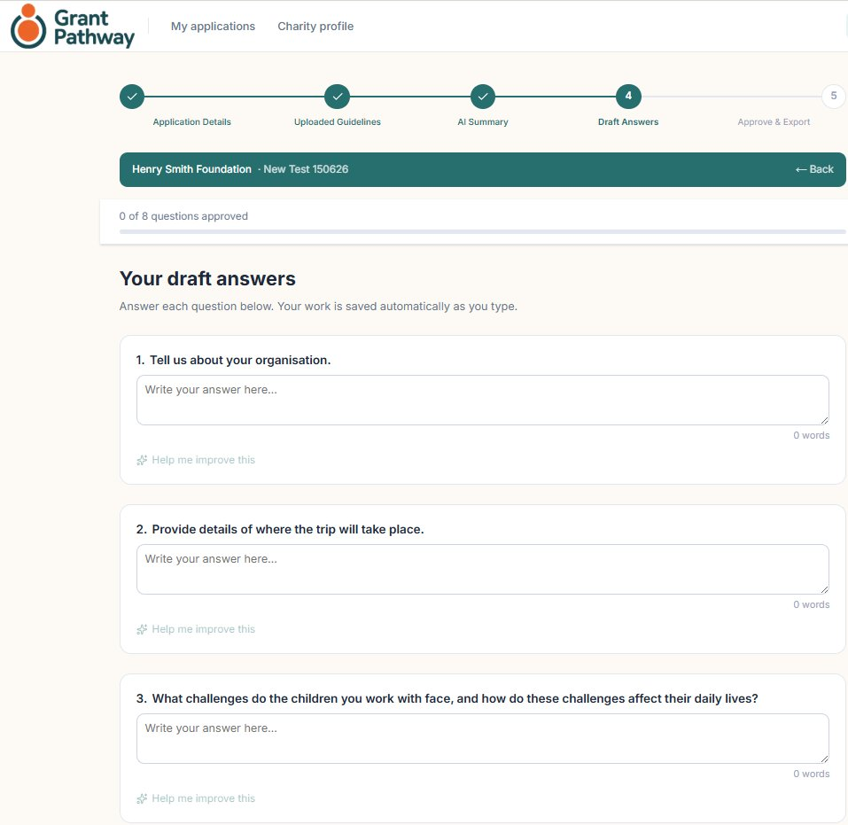

Writing Your Answer
Click inside the answer box beneath each question and start typing. Your answer is saved automatically as you write.

Word and Character Limits
If the funder has set a word or character limit, it is shown on the question card. A counter below the text box tracks how many words or characters you have used.

Getting AI Help
Click Help me improve this beneath any answer to ask the AI to refine the text. The AI will refine the structure and clarity of your answer while keeping your original wording and staying within the word limit.

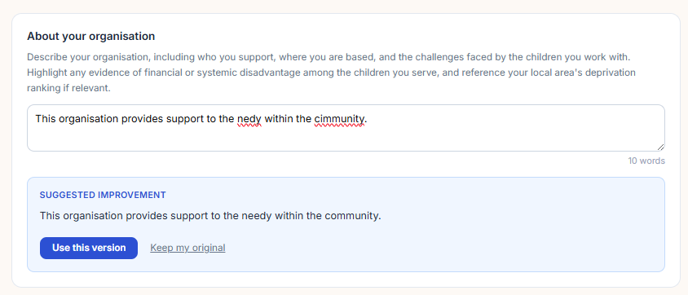
The AI may refine sentence structure and correct spelling, but will not replace your content or change your intended meaning.
Once complete, you can choose to use the refined version or keep your original text.

Sections with Financial Information
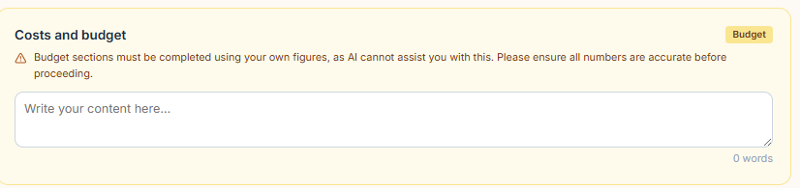
Note: Sections containing financial information have no AI assistance available. Your text will appear exactly as entered, ensuring there is no uncertainty about AI involvement in the financial figures.

Approving Answers
Once you have entered an answer, an approve option will appear.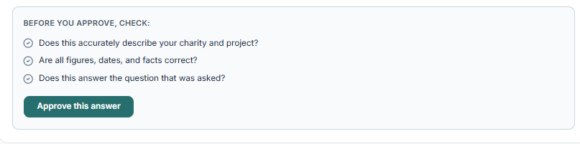

Once you are happy with an answer, click Approve. The progress bar at the top of the page shows how many answers you have approved.
You must approve all answers before you can proceed to the next stage. If you edit an approved answer, the approval is removed and you will need to re-approve it.

The Ready to Assemble button will be inactive until all sections are approved. Once all approvals are in place, the button will become available
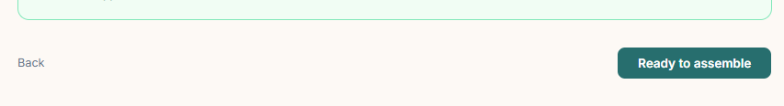

8. Prior Export
Before assembling the application, Grant Pathway will ask you to confirm that the financial content has been reviewed by a senior member of your team.
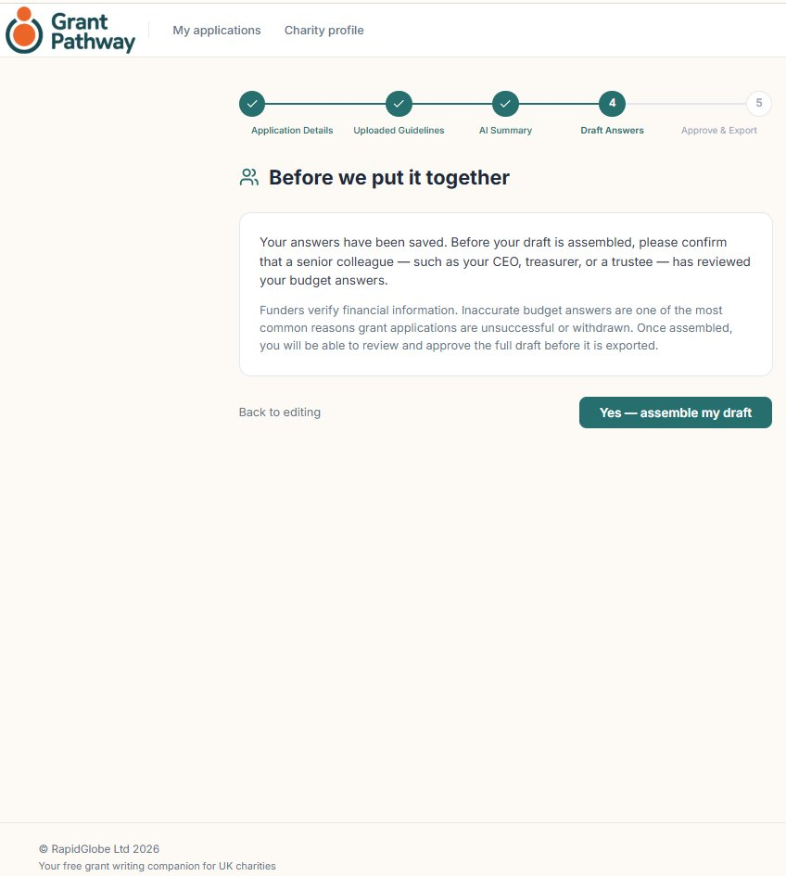

When you are satisfied that the financial information has been verified, click Yes — assemble my draft.

9. Review
Before exporting, Grant Pathway will ask you to do a final review of your answers. Take a moment to review each answer. To make changes, click Back to return to section 9. Once you’re satisfied, confirm your approval: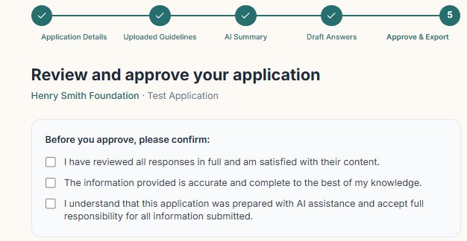

10. Export
Once you have given final approval, the download buttons will become available.
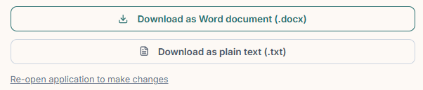

When you are ready, click Download as Word document to export your application. Grant Pathway produces a clean Word (.docx) file containing all your answers, formatted and ready to submit.

Tip: Save a copy of the Word document as soon as you download it. Grant Pathway stores your answers securely, but having a local copy is good practice before you submit.

Part B — First-Time Setup
Follow these steps the first time you use Grant Pathway. Once your account and charity profile are set up, return to Part A, Section 1 to begin your application.

12. Before You Start

Grant Pathway can currently handle applications for the following funder organisations:
- Idlewild Trust
- A B Charitable Trust
- Clothworkers’ Foundation
- Henry Smith Foundation
- Wolfson Foundation
- Lloyds Bank Foundation
- Foyle Foundation — Main Grants
- Walton Charity — Community Grants
- Nationwide Building Society — Community Grants
- Motability Foundation
- Garfield Weston Foundation
- City Bridge Foundation

Please have the funder’s guidelines document ready — you will need it at step 6. It can be a Word or PDF file. If you don’t have one, copy the relevant sections from the funder’s website and paste them in at step 6.
If your funder is not listed, you can request it to be added.

- Have your charity name and registration number to hand.

13. Creating Your Account

Go to grant-pathway-three.vercel.app and click Register — it’s free in the top right corner.
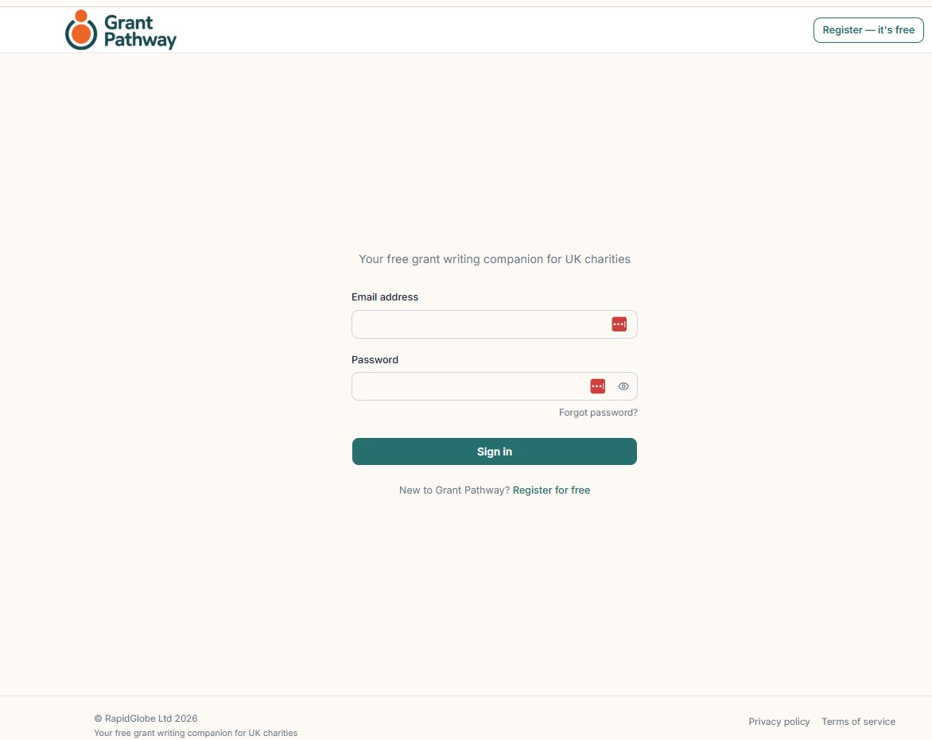
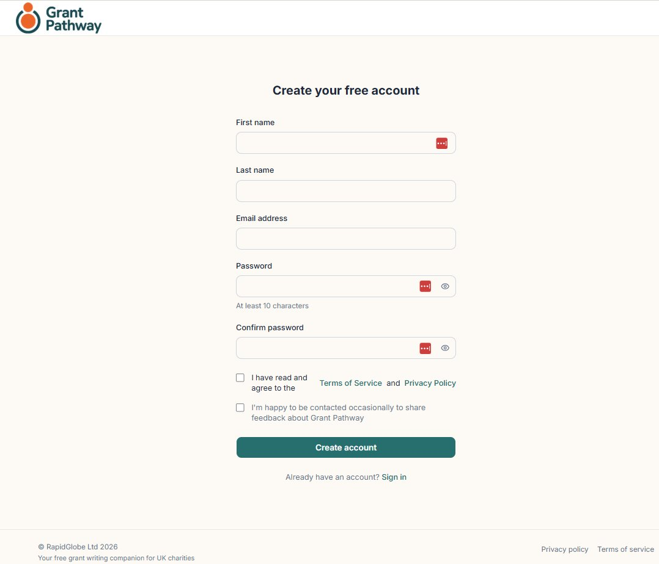

Fill in the following fields:

- First name / Last name
- Email address — use your work email address. This will be your login.
- Password — choose a password of at least 10 characters.
- Confirm password
- Terms of Service and Privacy Policy — tick to confirm you have read and agree to both.
- I’m happy to be contacted occasionally to share feedback about Grant Pathway — tick this optional box if you are happy to be contacted for feedback purposes.
Click Create account. Grant Pathway will send a verification link to your email address.
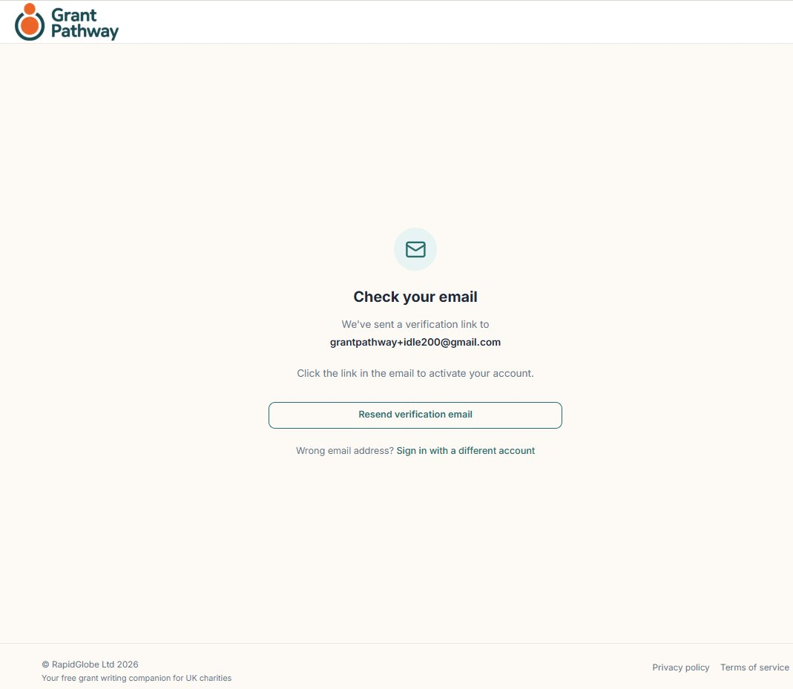
Click the link in the email to activate your account. If the link has expired, click Resend verification email on the screen that opens.
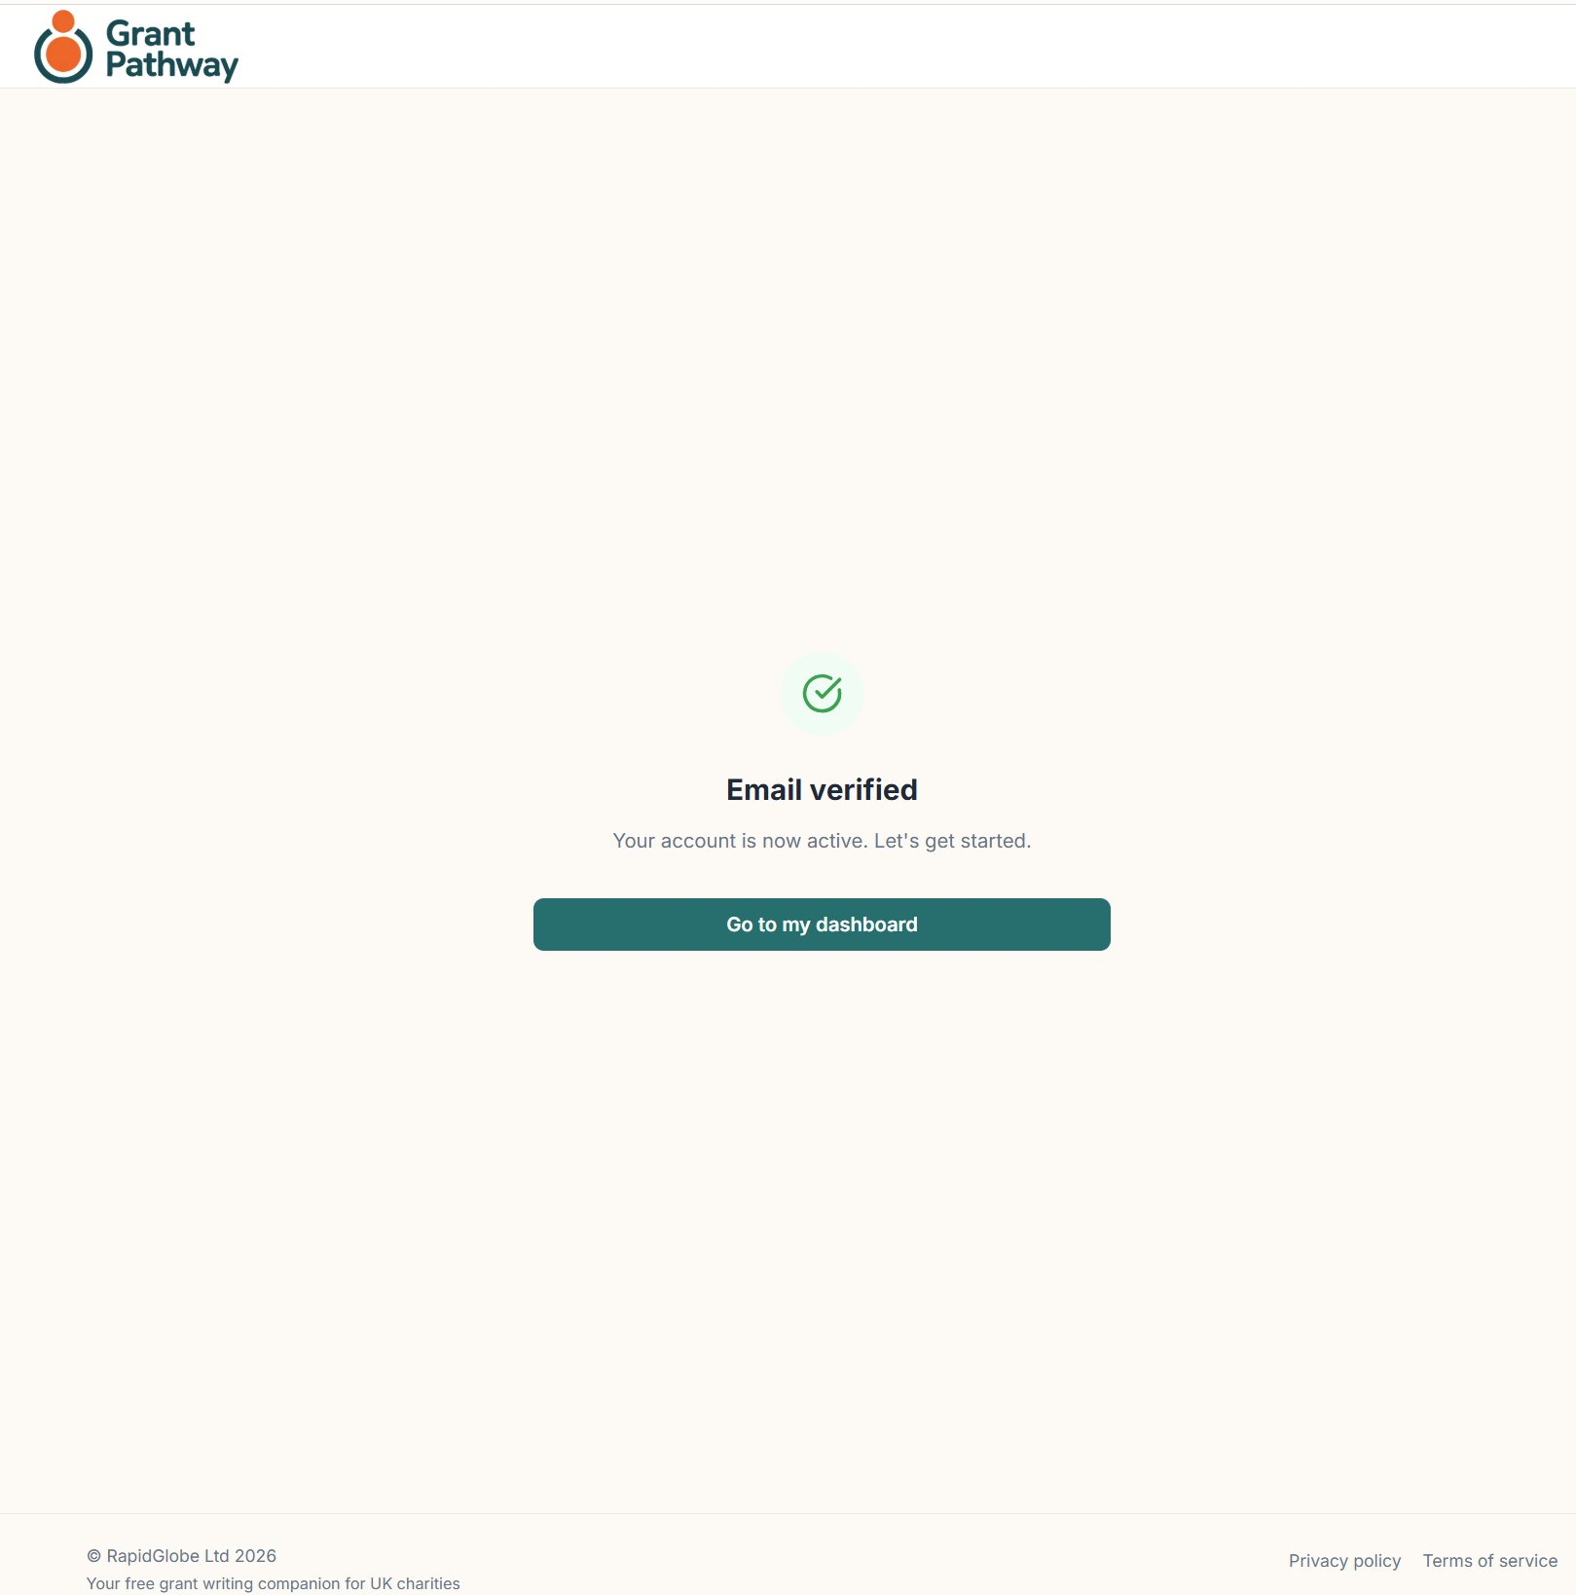
Once your email is verified, you will see a confirmation screen. Click Go to my dashboard to continue.
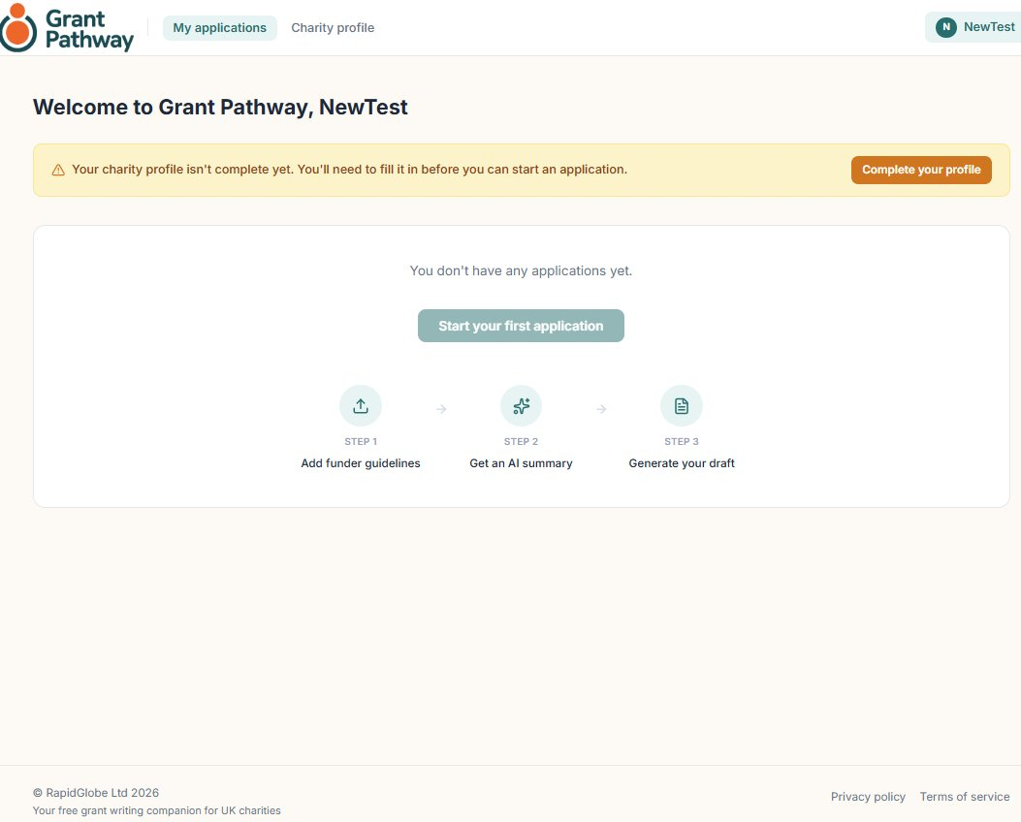

14. Setting Up Your Charity Profile

When you first sign in, a banner will prompt you to complete your charity profile — you must do this before starting an application. Click Complete your profile to open the profile form. You can also return to it at any time via the Charity profile link in the navigation bar.
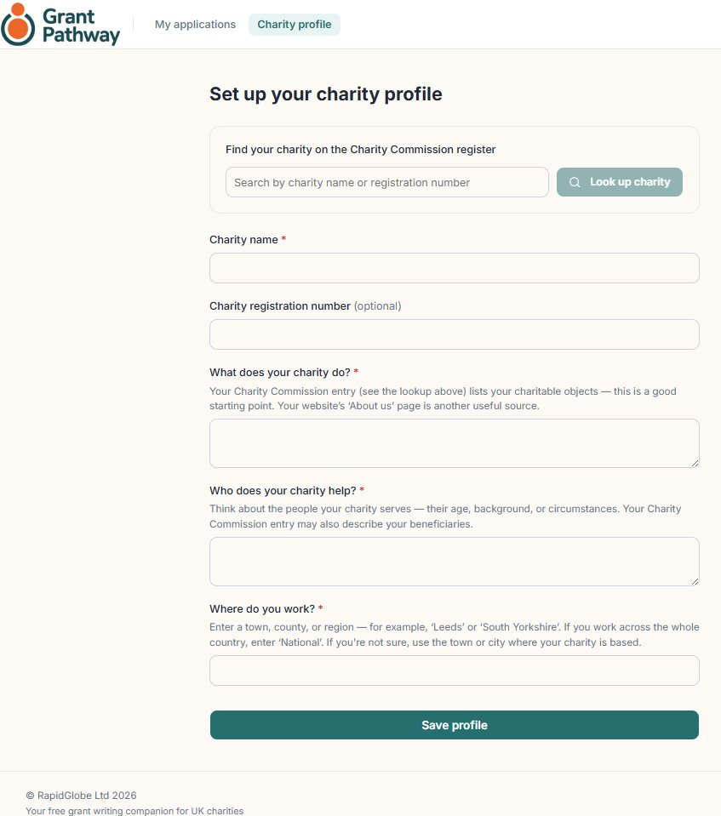
The information in your charity profile is used to personalise the AI-generated content in your applications.



Enter the charity name or registration number in the search box, then click Look up charity.
If the charity is found on the Charity Commission database, What does the charity do and Who does your charity help will be populated automatically. Complete the Where do you work section, then click Save profile.
If the charity is not found, complete the following fields manually, then click Save profile:
- Charity name
- Charity registration number (optional)
- What does the charity do
- Who does the charity help
- Where do you work

Grant Pathway will display a “Profile saved” confirmation screen with the message: “Your charity profile has been saved. You’re ready to start your first application.”
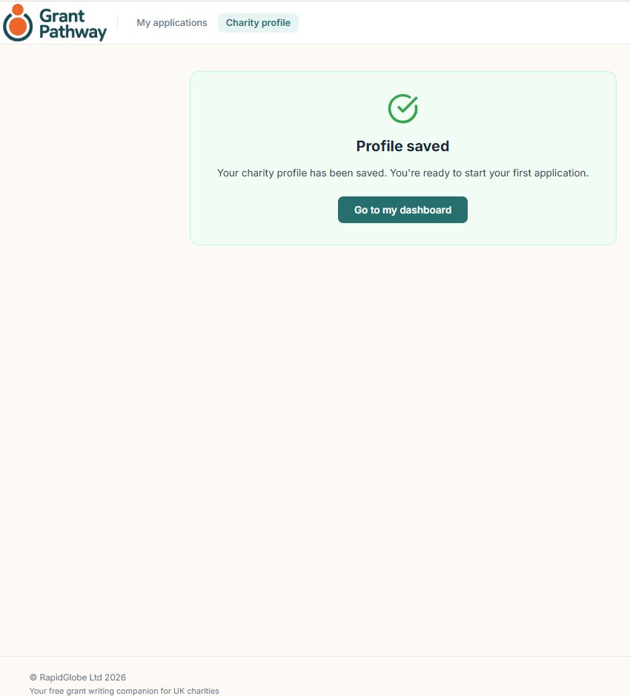
Click Go to my dashboard.
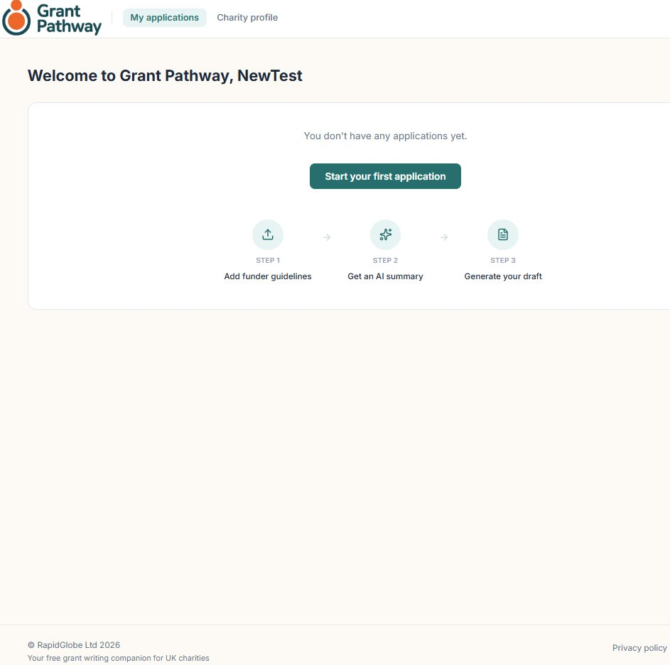
Click Start your first application to begin, and then go to page 3.

15. Managing Your Account
To access your account settings, click your user icon in the top right corner of any page and select Account settings.
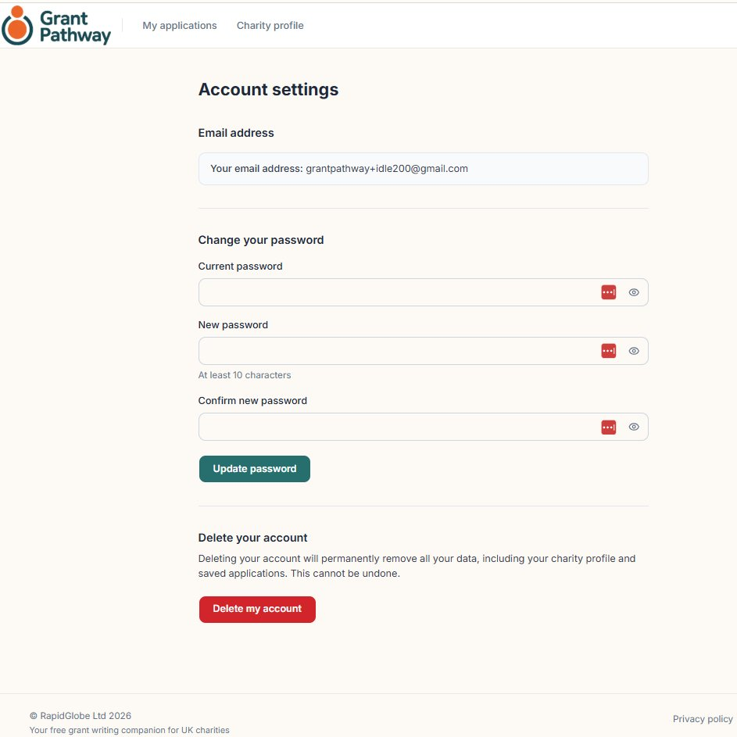
From the Account settings screen you can:
- Charity profile — update your charity’s name, registration number, or descriptions at any time.
- Change your password — enter your current password, then your new password (at least 10 characters), and click Update password.
- Sign out — click Sign out to end your session.
- Delete your account — permanently removes all your data including your charity profile and all saved applications. See below.

Deleting Your Account
Clicking Delete my account will take you to a confirmation screen. The following will be permanently deleted:
- Your charity profile
- All your grant applications and AI-generated content
- Your account and login details
To confirm, type DELETE in the confirmation box and click Permanently delete my account. This action cannot be undone. Click Cancel to return to Account settings without deleting.
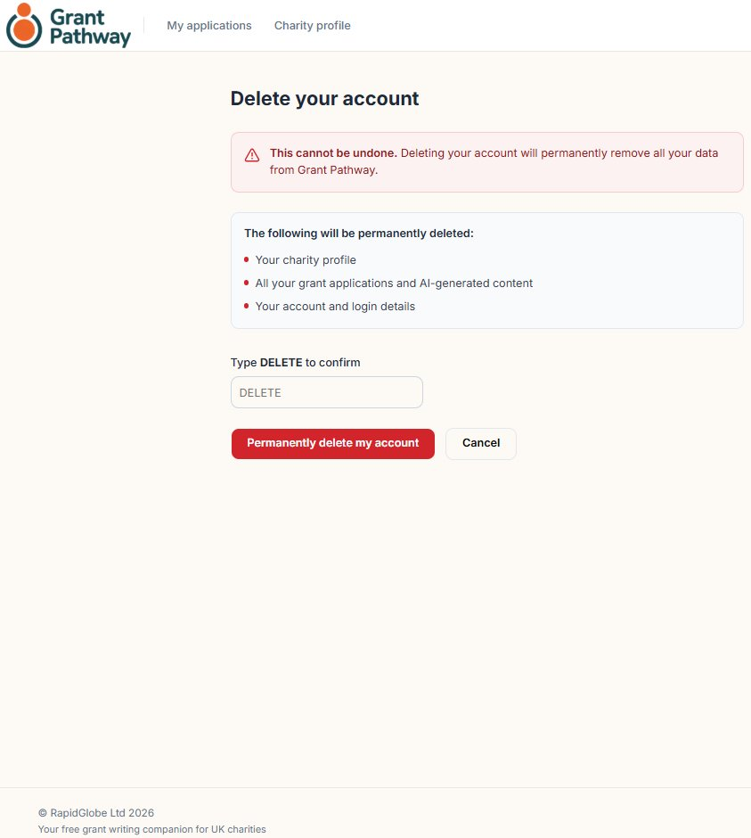

16. Application Status — What the Labels Mean
Each application on your dashboard displays a status label showing where it is in the process.
- Not started — the application has been created but no answers have been entered yet.
- In progress — answers have been started but not all sections have been approved.
- Approved — all answers have been approved and the application is ready to export.
- Exported — the application has been downloaded as a Word document.

17. Need Help?

If you have a question or run into a problem, contact the Grant Pathway team at:

wjokhia@rapidglobe.com

Please include a brief description of the issue and, if possible, the name of the funder you were working on.

Grant Pathway is provided free of charge by RapidGlobe Ltd (company no. 05615649) as a service to the UK charity sector.

